From February to April of 2007, I worked as customer solutions lead at Itiva Digital Networks. During that period I worked on adding a statistics function to the customer interface portal. The Portal was based on the LAMP stack. The Linux was Centos (RHEL 3.4), Apache (2.0.52) , community MySQL (server 5.0.27) , and PHP 5.1.6 . I have duplicated this stack on a older ‘home’ machine the following diagram shows my home network:
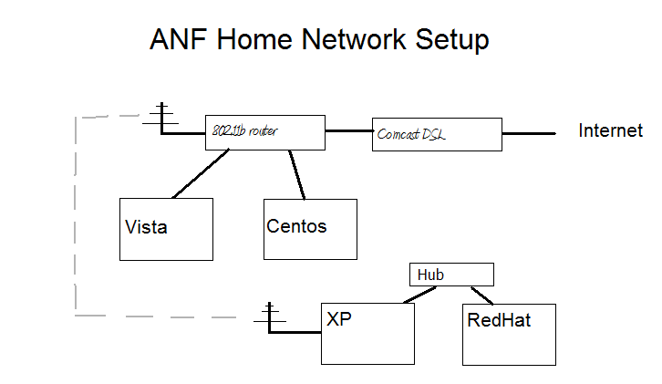
LAMP-MYSQL Information

I needed to install and configure MySQL 5, Since this was not supplied, “yum upgrade” was required. Apache and PHP were similarly upgraded and configured.

[root@centos includes]# mysql -p
Enter password:
Welcome to the MySQL monitor. Commands end with ; or \g.
Your MySQL connection id is 40 to server version: 5.0.27

Type 'help;' or '\h' for help. Type '\c' to clear the buffer.

mysql> show databases;
+--------------------+
| Database |
+--------------------+
| information_schema |
| mysql |
| newmesh_content |
| test |
+--------------------+
4 rows in set (0.00 sec)

mysql> use newmesh_content;
Reading table information for completion of table and column names
You can turn off this feature to get a quicker startup with -A

Database changed
mysql> show tables;
+---------------------------+
| Tables_in_newmesh_content |
+---------------------------+
| click_tracking |
| customer_owns_resource
| customers |
| global_settings |
| resources |
| support |
| template |
+---------------------------+
7 rows in set (0.00 sec)

To make the system work Virtual hosting was used, virtual web servers at cp.itiva.nxt and video.itiva.nxt were set up in the apache configuration files, and similar changes made to the local client’s host table.

The following are views from the working server:

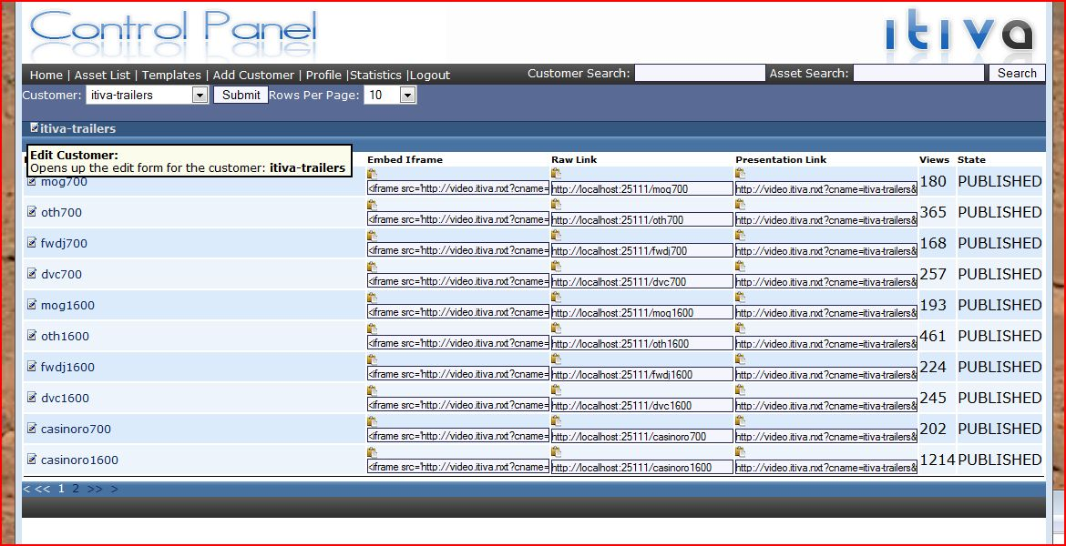

After login, the initial customer splash screen is presented. Starting on April 1st, I was asked to add a statistics function to the existing portal. One week was spent designing and documenting the proposed requirement. Coding began a week later. While substantial progress was made, the project was terminated on April 13th.

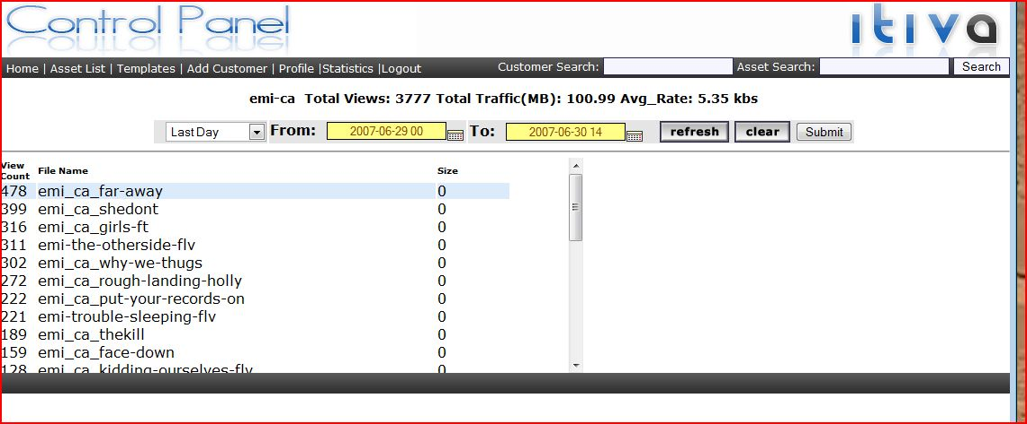

This prototype begins to access existing portal data and present it in a form suitable for statistical analysis. Ultimately the goals were to present graphical representations of the data, plus collate statistics from multiple NOCs. Since the schema of the NOC database was never made available, further progress was impossible. A location map feature and graphics library were added to the available tool sets, but never integrated.

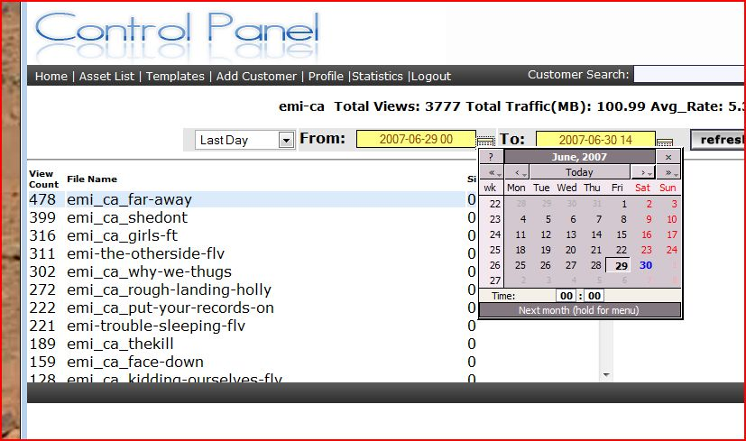

Since the time range for the statistics was important, the JavaScript library jscalander was incorporated into the page.

The following table lists the php scripts used:

admin_customer_list.php dosomething.php jscalendar
admin_templates.php dump.html list_resources.php
basic_template.php file_types.php main.css
bigmess.html footer.php mess.html
button_clear.gif form_add_resource.php mess.php
button_refresh.gif form_admin_profile.php nav_class.php
calendar-en.js form_customer.php show_ftp_assets_ajax.php
calendar.gif form_page_rows.php show_resources.php
calendar.html form_support.php statlist.php
calendar.js form_template.php style.css
calendar-setup.js functions support_dump.php
config.php header.alan test.php
date_test.php header.php widget.php
db.php index.html

Sample php code:

<?php

include('db.php');

$cid = '03';
$totalviews = 0;
$totalGB = 0;
$avgrate = 0;

$sql = "select DISTINCT customer_name,cid,rid,resources_rid,human_name,view_count,file_size from customers, customer_owns_resource, resources where (resources.rid=customer_owns_resource.resources_rid) and (customer_owns_resource.customers_cid=customers.cid) and (customers.cid='$cid') ORDER BY view_count DESC";

$rslt = mysql_query($sql) or die("Query failed");
echo '<div id="stat_table" style="overflow:auto; height:240px; width:650px">

<div id="stat_table_header"></div>
<table border=0 cellspacing=2 cellpadding=0 width="90%">
<tr style="font-size: 10px; font-weight: bold">

<td style="width: 35%;">
View Count
</td>

<td>
File Name
</td>
<td>
Size
</td>
</tr>

<tr style="background-color:#DBEBFB">
';
While ( $info = mysql_fetch_array( $rslt ) )

{

Echo "<td>",$info['view_count'],"</td><td>",$info['human_name'],"</td><td>"
,$info['file_size'], "</td></tr>";

}
echo "</table></pre>";
mysql_close();

?>

This code produces the scrollable text box shown in the figures.

Thanks. I can demonstrate a working version of this code for you, if you wish.

